Cuckooing and County Lines

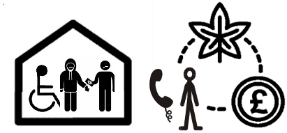
This document tells you about Cuckooing and County Lines.

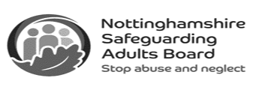
This information is from the Nottinghamshire Safeguarding Adults Board.

What is Cuckooing?

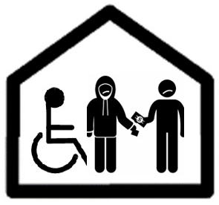
Cuckooing is when criminal gangs take over someone’s home to use as a base where they can sell and use drugs, as well as for doing other things that are against the law, like County Lines.

What does County Lines mean?

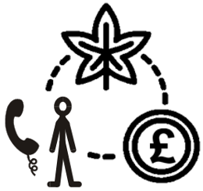
‘County Lines’ are the phone numbers (lines) that criminal gangs who move drugs from city to countryside areas use to sell drugs.

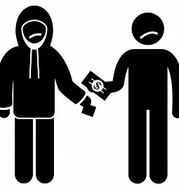
Criminal gangs use violence to get rid of
local drug dealers and use children and vulnerable adults to move and sell drugs.

Who do Cuckooing and County Lines affect?
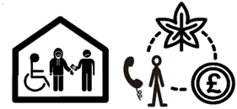
People more likely to be affected by Cuckooing or County Lines include:

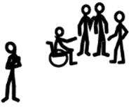
- People living alone or who are lonely.


- Single parents.


- Sex workers.


- Children.


- Vulnerable adults (who might not see themselves as vulnerable).

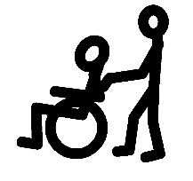
- People with physical health problems.

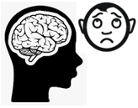
- People with mental health problems.


- People who misuse drugs and alcohol.

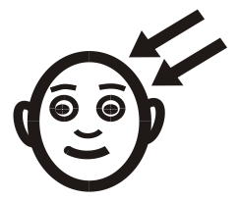
- People with learning disabilities.

How do criminals get people involved?


There are lots of ways someone can become involved in drug trafficking, and sometimes victims might not know they are doing things that are against the law.

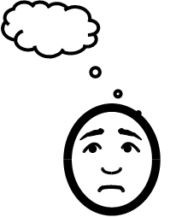
People can be tricked into helping criminals do things that are against the law.

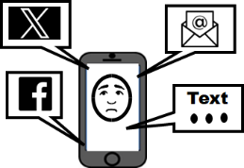
Criminals can pretend to make friends with their victims by using social media, and then blackmail them.

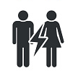
Some criminals may start a relationship with their victim to control them, their money and home, and even make the victim move and sell drugs.

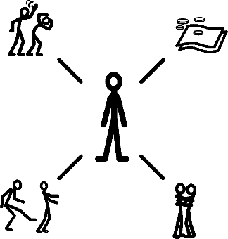
A criminal might pretend to be someone’s friend, romantic partner, or just a kind person before hurting or abusing their victim, scaring them or making them give them money, including money for drugs they first said were free.
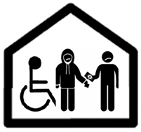
The criminals do these things so they can take control of the person’s home.

What happens because of this?


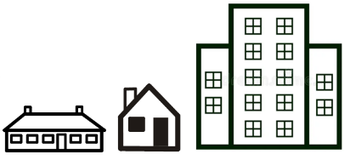
Gangs can use lots of addresses and can move quickly between people’s homes for a few hours, days or longer.



Criminals work from a property and not the street, so it is harder for the police to find them.

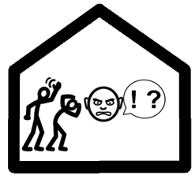
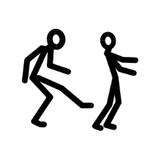
Victims may be forced out of their homes or decide they must leave.

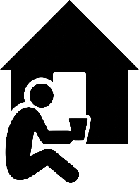
This means victims can become homeless and the gangs can do more crimes.

Signs of Cuckooing

Things that show Cuckooing might be happening are:

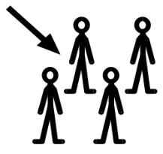
- Extra people at the house.

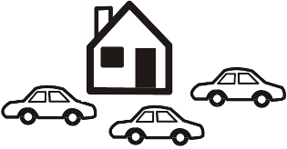
- More traffic outside the house.

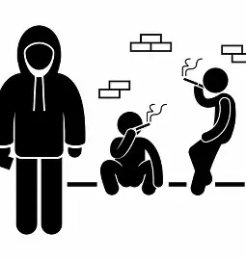
- More litter & anti-social behaviour.

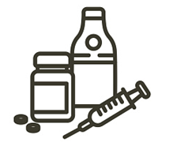
- Signs of drug use.

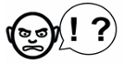
- Changes in someone’s behaviour.

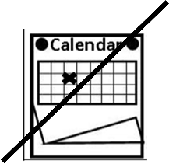
- Someone missing appointments and not saying why.

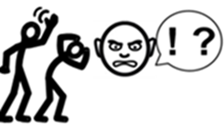
- Someone having new ‘friends’.

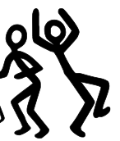
- More parties at a house.


- Changes in the amount of money someone has.

- Someone using more drugs.

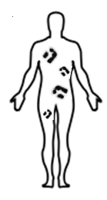
- Someone being physically hurt.


- Someone seeming dazed or checked out.

Who can help?
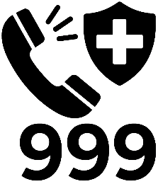
Phone the police on 999 if it is an emergency.

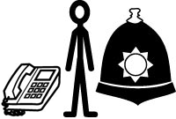
Phone Nottinghamshire Police on 101 if it is not an emergency.

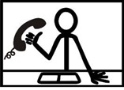
Phone the Modern Slavery Helpline on 0800 0121 700.


You can also report Modern Slavery online.
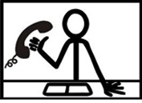
If you are worried about an adult at risk, phone MASH on 0300 500 80 90.


You can report abuse or neglect of an adult online.


You can email the Slavery Exploitation Team at msvp@nottinghamcity.gov.uk

Links in this document

Nottinghamshire Safeguarding Adults Board
nsab.nottinghamshire.gov.uk/

Report Modern Slavery online
modernslaveryhelpline.org/report

Report abuse or neglect of an adult online
nottinghamshire.gov.uk/care/safeguarding/adult-safeguarding-hub/professionals-report-abuse

This easy read was first published 28 April 2026.
This information was last updated 28 April 2026.

