Safeguarding Adults Review (SAR)

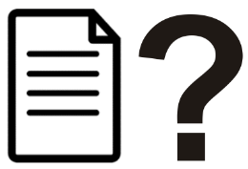
This easy read tells you about Safeguarding Adults Reviews (SARs).

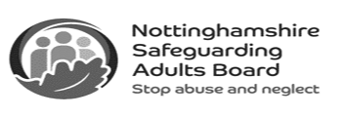
This information is from the Nottinghamshire Safeguarding Adults Board.

What is the Safeguarding Adults Board?
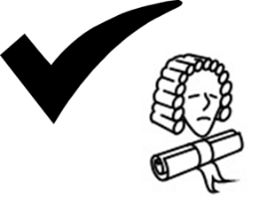
By law every Local Authority must have a Safeguarding Adults Board (SAB).

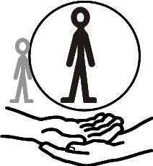
The SAB makes sure that safeguarding is working well to protect vulnerable adults.


The other things the SAB must do are:


- Publish a plan of what they want to do next and write about what they have done in the previous year.

- Make sure Safeguarding Adults Reviews happen when necessary.

What is a Safeguarding Adults Review (SAR)?


A Safeguarding Adults Review must happen when:

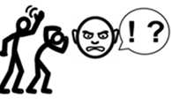
- An adult dies or is seriously harmed because of known or suspected abuse or neglect.

and

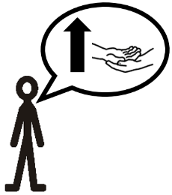
- It is thought that people involved in safeguarding could have done things differently to protect the adult better.

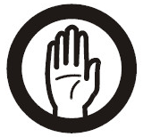
Safeguarding Adults Reviews happen to look at what people could have done differently to have stopped harm or death.


This is so things can be done differently in the future to try to stop similar harm from happening again.


The purpose of the SAR is not to blame or punish anyone for what has happened.

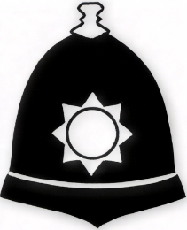
People who have caused harm can still be in trouble with the law but that is separate from the Safeguarding Adults Review.


Safeguarding Adults Reviews can also show what is working well.

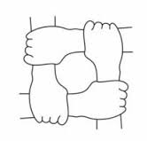
Any ‘partner agency’ can ask for a Safeguarding Adults Review to happen.

Who is involved in a Safeguarding Adults Review (SAR) and what happens?

Safeguarding Adults Boards lead SARs, but other people are brought in to help.


These people are not connected to anyone involved in the review.
They are sometimes called “Independent Authors.”


Independent Authors have lots of experience, and know a lot about things like crime, health, and social care.

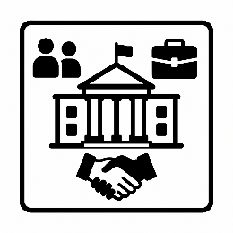
Organisations who were involved in the care and treatment of the person under review must help with the SAR.

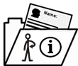
They must give information to the people doing the review, including information about what happened and when.


Sometimes, there are interviews to ask people questions about what happened.


The Independent Author writes their report, and shares drafts until a final version of the report is agreed.

What happens when the SAR is finished?

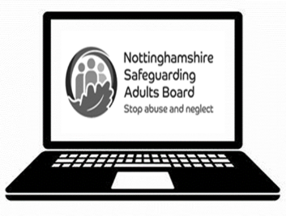
When the Independent Author has finished their report, it is usually put on the Safeguarding Adults Board’s website.


The Safeguarding Adults Board make an action plan telling people what they should do to make sure that the lessons learned from the review are put in place.


Safeguarding Adults Boards then make sure the action plans happen.

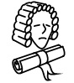
By law, Safeguarding Adults Reviews must be done, but the law does not say that the actions suggested in the report must happen.

More information


There are different types of review that can happen.

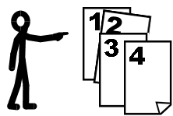
The Safeguarding Adults Board decide what sort of review is best to stop deaths or serious harm from happening again in the future.
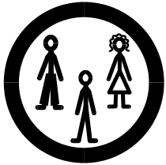
The person who has been abused and/or their family is often involved in the Safeguarding Adults Review.

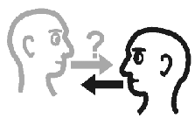
A good Safeguarding Adults Review report should answer questions for families and friends of adults who have died or been seriously abused or neglected.

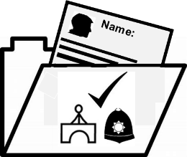
The Safeguarding Adults Board should think about how the Safeguarding Adults Review can fit together with any other investigations that are happening, like a criminal investigation or an inquest.


This is because it will make things easier for people involved, like family members and staff, and can stop duplication- which is things happening more times than necessary.

Links in this document
Nottinghamshire Safeguarding Adults Board
nsab.nottinghamshire.gov.uk/

This easy read was first published 28 April 2026.
This information was last updated 28 April 2026.

