Mate Crime
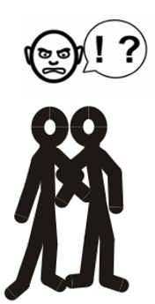
This easy read document tells you about mate crime.


This information is from the Nottinghamshire Safeguarding Adults Board.

What is mate crime?

Mate crime is when someone is abused by someone they thought they could trust, such as a close friend, a family member or a carer.

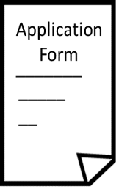
People are more likely to report abuse by a stranger but might find it difficult to report someone they have a relationship with.
Police report

Who is more likely to be a victim of mate crime?
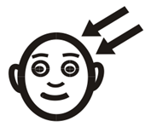
- People with learning difficulties.


- People with autism.

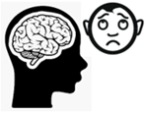
- People with mental health problems.

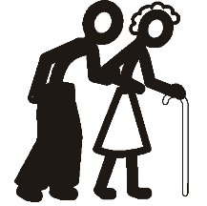
- Vulnerable or older people.

Mate crime as hate crime


Mate crimes can sometimes be classed as disability hate crimes, and people who do these sorts of crimes can be in more trouble with the police and the law.

Examples of mate crime
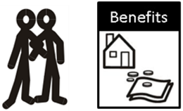
- ‘Mates’ only turning up on benefits ‘payday’.

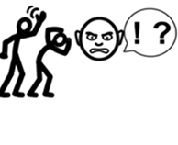
- Being physically beaten or hurt for others’ entertainment.


- Being made to feel worthless or insulted for others’ entertainment.

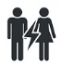
- Being made or persuaded to do sexual acts, including on other people.

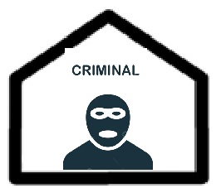
- ‘Allowing’ their homes to be used by others, often for criminal purposes.

Signs of mate crime
Things that show mate crime might be happening include:


• Changes in someone’s routine or behaviour.


- Changes in someone’s appearance.


- Changes in the amount of money someone has.

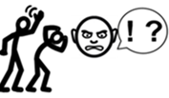
• Being controlled or badly treated by a ‘friend’.

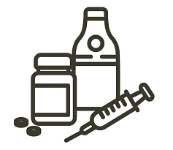
• Parties and drug use.
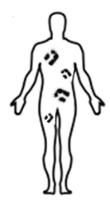
- Someone having injuries they can’t explain.


- Someone’s belongings going missing.

Spotting mate crime

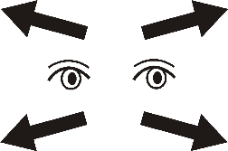
Mate crime can be hard to spot as some people don’t know they are being abused or know that it is a crime.

Difficulties in reporting mate crime


Some victims might not want to report family or friends who abuse them. There are lots of reasons for this, such as:


- They might be scared that they won’t be believed.

- They might be scared to report it in case the abuser finds out.


- They might not want their ‘friend’ or family member to be in trouble.


- They might be afraid of losing the relationship.

Who can I ask for help?

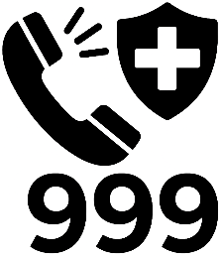
Phone the police on 999 if it is an emergency.

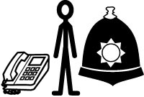
Phone Nottinghamshire Police on 101 if it is not an emergency.

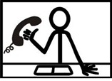
If you are worried about an adult at risk in Nottinghamshire, phone the Multi Agency Safeguarding Hub (MASH) on 0300 500 80 90.


You can also report abuse or neglect of an adult online.

Links in this document
Nottinghamshire Safeguarding Adults Board
nsab.nottinghamshire.gov.uk/

Report abuse or neglect of an adult- MASH
nottinghamshire.gov.uk/care/safeguarding/adult-safeguarding-hub

This easy read was first published 28 April 2026.
This information was last updated 28 April 2026.

