Making Safeguarding Personal

This easy read tells you about Making Safeguarding Personal (MSP).


This information is from the Nottinghamshire Safeguarding Adults Board.

What is Making Safeguarding Personal?


Making Safeguarding Personal is a way to safeguard adults that:


- Is person-centred. This means professionals thinking about what matters to you.


- Is outcome focused. This means it looks at what you want to happen.


- Uses different ways to support you.


- Listens to your views, wishes, feelings and beliefs when deciding what to do.

Why Making Safeguarding Personal matters

Research shows that Making Safeguarding Personal is good because:


- You are more likely to be happy with what happens.


- Abuse or neglect is less likely to happen again in the future.


- It empowers you and gives you control in your own life, health and wellbeing.

How will this happen?


Professionals working with you will listen to your opinions and what you want to happen at the beginning, middle and end of the safeguarding process.

This is sometimes explained as “No decision about me without me.”


The focus will be on what you want to happen because of the safeguarding process (the outcomes.)


How the outcomes are achieved will be recorded, and if the outcomes do not happen, the reasons why will be written down.

A plan will be made with you, so you know how to stay safe.

What professionals working with you should do

They should always treat you with dignity and respect.


They should talk to you and listen to you about what you want to happen at the start, middle and end of the safeguarding process.


They should ask you who you would like them to talk to and involve in any enquiry.

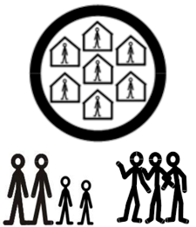
This includes thinking about your family, friends and wider community support, and thinking about how to support the people who support you.

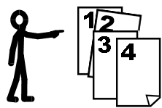
They should talk to you about your options and tell you what is not available or can not be achieved.

They should make a plan with you, so you know how to stay safe.

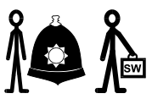
They should work well with other professionals to prevent neglect and abuse.


They should work with you to recognise the potential for abuse or neglect and develop support systems to keep you well and safe.


Professionals should always work within the 6 principles of the Care Act.


The 6 principles are:

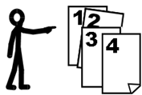
- Empowerment.
This means giving people choice and control in their own lives.

- Prevention.
This means stopping harm from happening.


- Proportionality.
This means the response is balanced and right for the problem.


- Protection.
This means keeping people safe.


- Partnership.
This means working together.


- Accountability.
This means taking responsibility for our own actions.

Links in this document
Nottinghamshire Safeguarding Adults Board
nsab.nottinghamshire.gov.uk/

This easy read was first published 29 April 2026.
This information was last updated 29 April 2026.

